**Major Historical Markets Downturns and Five Factor Model**

Almost 11 years after the Lehman’s sudden collapse and the Federal Reserve bailing out AIG from the cliff edge, we are surrounded with voices saying that we are counting down to our next financial crisis in a year or two, although currently we are still safely moving forward with rosy economic indicators. Each crisis or market crash was extraordinarily damaging to households, social security and political stability, and may be triggered by various factors, including political affairs, internal economy, etc. As for how to navigate ourselves across the future unknown dark periods, history is a good place to look for answer. This research report will lay a foundation for future research reports to come by giving a brief overview on the US extreme events that had big impacts on the equity market since 1960s. In the second part of this report, we will examine and discuss the performance and characteristics of one of the most popular financial models, the Fama French 5 factor model, in the past decades, especially when those “extreme events” happened.

[Type the document subtitle]

1. ***Historical Market Downturn Triggers***

Market downturns can be triggered by various factors, including economic recessions, asset bubbles, political uncertainties, etc. And the triggers can be originated from overseas and be contagious as the global financial markets tend to move together. Figure 1 summarizes some of well-known historical bull and bear market periods and some significant historical events that triggered market downturns. In this session, we segment the historical market downturns by their triggers and will have a brief review on each one of them.

|  |
| --- |
| *Figure 1:*  *Cumulative Return of S&P 500 in Bull and Bear Market* |

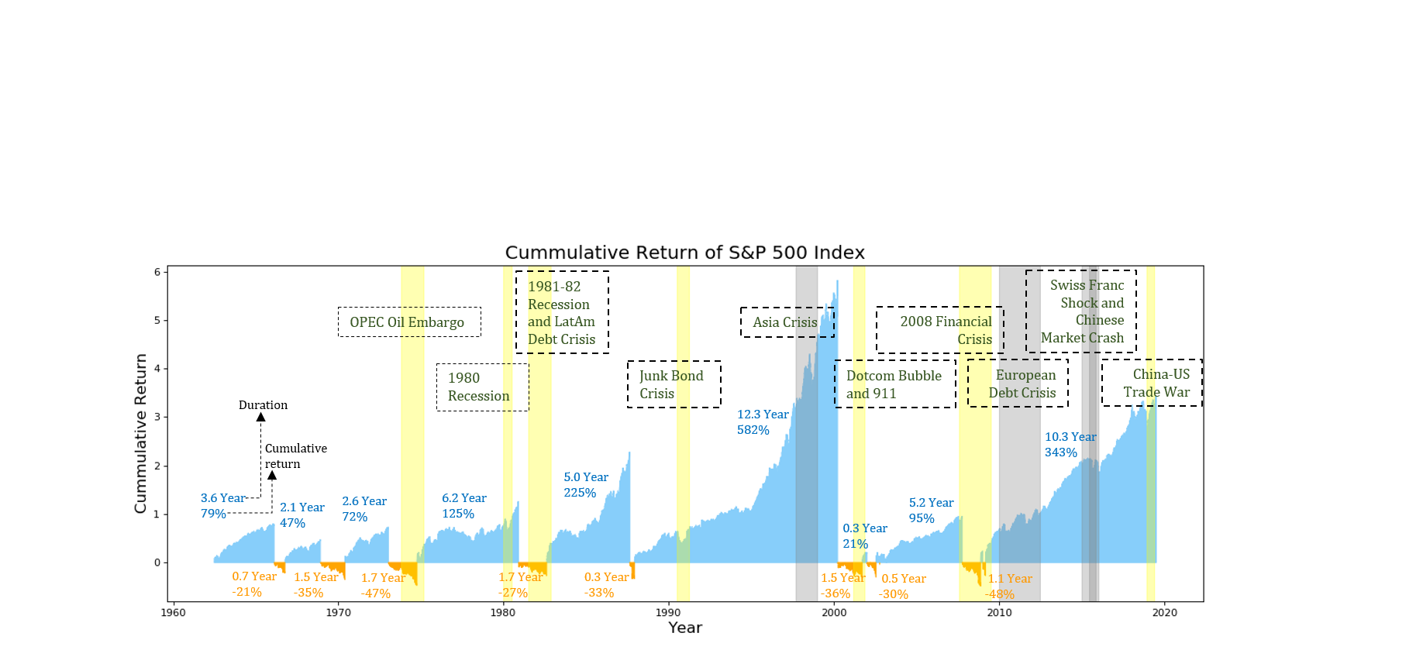

***Economic Recession***

***1981-82 Recession***: In the 1970s, the Fed adopted a “stop-go” monetary policy, which was based on the trade-off between unemployment rate and inflation on Phillips Curve. In “go” periods, the Fed would fight unemployment by lowering interest rate, while in “stop” periods, the Fed would tighten the monetary policy to control inflation rate. However, in mid 1970s, the Fed seemed to be unable to balance between inflation and employment as the two indicators tended to mount together. The unemployment rate reached its peak in May 1975 at 9% and trended down slightly in late 1970s. Believing that a high Inflation rate would be harmful to the economy over an even longer time, the Fed again tightened monetary policy after the inflation peaked at 11% in Jun of 1979. The cost was inevitably a rise on long-term interest rate. 10-year Treasury yield was around 15% in 1981. Economic sectors that were more dependent on borrowing were affected significantly, and unemployment rate started to climb to almost 11% at the end of 1982, the highest level in any recession happened in recent 40 years. During the recession period, the S&P 500 index dropped by 27% from November 1980 to August 1982.

***International Debt***

***European Debt Crisis***: The European Debt Crisis is a long-lasting crisis with complicated and varied causes. The first country to trigger the crisis was Greece, whose leading industries (shipping and tourism) were largely affected by the 2008 global financial crisis. The Greek government spent aggressively to keep the economy from falling and finally the deficit was announced to be 12.9% of Greece 2009 GDP, while the limit set by EU is 3%. Being unable to repay its huge debt, and unable to further borrow from the market, the Greek government started to seek for bailout loans from EU and IMF.

A working paper from European Central Bank found that major transmission channels of the euro debt crisis to countries outside eurozone were trade and economic links, while the financial channel turned out to be weak (Stracca 2013). Although US export to Europe only amounted 2% of US GDP, and nor US economic activities were tightly linked to the European countries in debt crisis, US could be affected indirectly by other developed countries in the eurozone. Economist at Citigroup found that GDP growth of US and Europe were moving three times closer in 2000s than a decade before (Irwin 2011).

Beyond actual economic activities, market sentiment is also contagious across the world. The spread out of risk aversion impacted the decision-makings of government officials, corporate leaders and investors, which enhanced the correlation among different financial markets around the world. ~~For example, US stock market moved in the same direction as German stock market 86% of the trading days in September 2011.~~

***LatAm Debt Crisis***: In August 1982, Mexico announced that they were not able to service the debt to US commercial banks and other overseas creditors, and other Latin American countries followed with same announcements shortly. The Debt Crisis originated from the skyrocketed Latin American borrowings from overseas creditors in 1970s. By 1982, the total Latin American debt held by the 9 largest US banks was 176% of those banks’ capital. Coincide with fighting inflation as the priority of the industrialized world, the Latin American countries found that their debt burdens were gradually beyond their affordable level as the interest rate for loans climbed under the tightening monetary policy.

***Asset Bubble***

***Dotcom Crash:*** As the personal computer gradually became a necessity in 1990s, the era of information technology arrived, and a large amount of internet-related companies were founded accordingly. Meanwhile, interest rate lower than the prior decades when the Fed fought high inflation with tightening monetary policy provided a favorable environment for the new tech companies to raise capitals and expand their business. Investors were enthusiastic about buying in any stock with “.com” suffix in the company name. In order to sustain the technology effect and grab larger market shares, the dotcom companies spent aggressively on marketing and promotion activities, and a lot of them consequently had to maintain operations under liabilities with easy money raised from various channels. On March 10, 2000, the NASDAQ Composite stock market index peaked at 5,048.62.

However, the carnival partially arose from low interest rate environment could not sustain any more afterwards when economy growth slowed down and the interest rate started to pick up. A large amount of dotcom companies were shut down and liquidated, and other more robust ones like eBay and Amazon, though survived, ended up with market capital evaporated by 86% on average. By the end of 2002, the stock market lost 5 trillion dollars compared to the prior peak. At its dip in October 2002, NASDAQ dropped by 78% from its peak.

***2008 Financial Crisis***: The 2008 Financial Crisis is considered to be the most serious financial crisis ever since the 1930s Great Depression. However, tracing back to the very beginning, it actually originated from some good intention of the government: in 1995, in order to encourage Fannie Mae and Freddie Mac to fulfill their lending obligations for affordable housing and reduce discrimination against low-income borrowers, the government started to allow them to buy subprime securities, among which Credit Default Swap (CDS), introduced by J.P. Morgan in 1994, was a notorious one during the later crisis.

The following ten years saw the government and financial industry gradually took on more risks: Fannie Mae lowering the credit requirements for low-credit borrowers in 1999, banks being allowed to run investment brokerages, regulations on CDS trading being relaxed at the same year, in 2004 the Securities and Exchange Commission’s (SEC) removal the leverage limit for companies with larger than 5 Billion assets, after which top banks started to use over thirty times leverage rather than twelve as restricted by SEC before. Meanwhile eleven times interest rate cuts were implemented since the Dotcom crash, and this further fertilized the soil of lending markets.

However, starting from 2006, the housing market started to cool down, and in 2007 the decline accelerated. The subprime mortgage industry collapsed, with many of the lending companies declared bankruptcy. And shortly, the collapse was spread to the broader financial sector as many banks and hedge funds had invested aggressively in mortgage-backed securities (MBS). The crisis quickly spread overseas as banks and hedge funds from outside US announced liquidity problem due to their massive holdings of MBS. Bear Stearns, the second largest underwriter of MBS, was the first iconic Wall Street investment bank to collapse: the company firstly bailed out its internal hedge funds with billions of dollars, which was not unmanageable compared to its 20 billion market cap at that time. But as the rating companies continued to downgrade its MBS and other holdings and a bank run happened later on, it soon ran out of liquidity in the down market and J.P. Morgan finally acquired it with financial support from the Fed in March 2008. In September, Lehman Brothers fell. Lehman was the largest MBS underwriter, and with a MBS portfolio that was four times as its shareholders’ equity, Lehman was more of a real estate hedge fund that an investment bank. Lehman’s bankruptcy triggered a 4.5% single-day drop in DJIA, the largest one since the 911 attack. AIG was afterwards bailed out by the Fed to avoid other economic sectors’ meltdown.

The Fed rescued the economy by more bailouts in other industries, and 3 rounds of Quantitative Easing (in 2008, 2010 and 2012 respectively) by massively buying in government bonds and MBS. After these manipulations, the Fed’s balance sheet ballooned from 900 billion to 4.5 trillion. It was not until the Obama’s economic stimulus plan was released that the public confidence was rebuilt and the 2008 stock market crash was finally ended in July of 2009.

***Black Swan and Algo Trading***

***Swiss Franc Crisis:*** Swiss Franc was always regarded as a safe haven currency. Due to the long-lasting European Debt Crisis, the demand for Swiss Franc continued to increase, putting a strong pressure on Switzerland’s export, which contributed to more than 70% of Switzerland’s GDP in 2013. Switzerland decided to peg the rate of Swiss Franc to 1.2 euros by printing Swiss Franc to purchase foreign assets and currencies when Swiss Franc appreciated. After three years of efforts to buying in massive foreign currencies, the Swiss National Bank (SNB) already grew a ballooned balance sheet. Meanwhile, as the euro continued to depreciate against US dollar, the SNB was faced with high risks of devaluation with Swiss Franc pegged with the weakening euro, as well as risks brought by a soaring inflation within the country. The EUR/CHF exchange rate dropped 20% within 1 min after the announcement, and it was disastrous to most FX traders who ended up with huge negative balance sheet, as they paid huge to winners but were unable to collect from losers who largely traded with leverage. A working paper by the Bank of England found that during the Swiss Franc crisis, computerized algorithmic (Algo) trading consumed liquidity and reinforced the price disruption in Swiss Franc currency pairs while the human traders did the opposite (Francis Breedon, Louisa Chen, Angelo Ranaldo, Nicholas Vause 2018).

The Wall Street was undergoing uneasiness during the prior several weeks due to the glooming economic indicators in multiple sectors, and this Black Swan event definitely compounded the pessimistic sentiment. Especially after BOA and Citigroup released their glooming earning figures in 2014Q4 and reported huge losses through the Swiss Franc crisis.

***1987 Stock Market Crash***: Monday, Oct 19 of 1987, is known as the Black Monday when global stock markets crashed. The crash firstly began from Hong Kong, and hit Europe afterwards and later on spread to United States. The US economy recovered from 1980s recession and the stock markets were booming accordingly. The DJIA increased by 44% from 1986 year end closing point 1,895 points to 2,722 points in August 1987.

On October 19, the crash firstly occurred in Hong Kong. The DJIA dropped by 508 points or 22.6% on October 19, which still remains to be the largest one-day percentage decline in the DJIA over the history. By end of October, the stock markets had fallen in Hong Kong by 45.5%, in United States by 22.7% and in the UK by 26.5%.

The causes of this crash are still debated. But a most commonly blamed one is the growing and massive use of program trading, which could blindly sell or buy stocks as markets fell or went up and therefore created extra self-inflicted volatilities. Thus, people have reason to believe that the booming market right before the crash can also be attributed to program trading. This is also when the circuit breakers or “trading curbs” was introduced to prevent the index price from a free fall under program trading.

***International Political Uncertainties***

***1973 OPEC Oil Embargo:*** In 1973, in order to gain leverage in the peace negotiations after the Arab-Israeli War, the Arab members of OPEC (Organization of Petroleum Exporting Countries) imposed an embargo banning petro exports to United States and other countries that supported Israel. Increasingly dependent on oil import, the US economy was greatly impacted as the oil price soared to double and finally tripled following the embargo. What made things worse was firstly the wage-price control implemented by President Nixon, who pegged the wage too high and forced businesses to lay off workers. And secondly a devaluation of US dollar triggered by Nixon’s taking US off the gold standard.

All these events together led to a long-lasting stagflation and negative GDP growths lasted for 5 quarters from 1973 Q3 till 1975 Q1, and unemployment rate reached a peak of 9% in May 1975. The crude oil price remained high even after the embargo against US was lifted in March 1974. At the peak, the crude oil price was 6 times the mid-1973 crude oil price level as the OPEC cut production for several more times. Starting from January 1973, the stock market was already undergoing one of the worst downturns in the history, and it was compounded by the OPEC Oil Embargo later on. From January 1973 to October 1974, the S&P 500 Index dropped by 47%.

***Terrorism***

***The 911 Attack:*** September 11, 2001 is an example of terrorism’s impact on equity market. To prevent a stock market meltdown, the NYSE and NASDAQ did not open for trading on the morning of 911 after the first hijacked plane crashed into World Trade Center at 8:46 a.m. When the two stock exchanges opened on September 17, the S&P 500 index declined by 11.6% and DJIA decreased by 1370 points within the day. The biggest drop occurred in the airline and insurance industry, especially in American Airline (39% decline) and United Airline (42% decline), whose planes were hijacked in the attack. However, as the public believed that US might enter into a war following the attack, sectors related to defense and military began to spike for a while.

1. ***Fama and French Five Factor Model***
2. ***Motivation of exploring factor model***

In our effort to develop daily rebalanced systematic equity trading strategies via latest machine learning approaches, we have found many challenges, among which, one of the biggest problems is the instability nature of the equity prices time series.

As there are 252 trading days in a year, twenty years will generate only about 5000 data points for a single stock. However, the global economic conditions can change rapidly in a twenty years of time duration, especially if we look at the economy history and the US equity market indices in the past 60 years.

It is not difficult to explain what caused most of the down periods of the market indices, however, the reasons behind each bull and bear periods are not the same or not even similar which makes it very difficult to draw meaningful patterns via purely quantitatively approaches. Think of dividing 5000 data point into 3 phases, each phase will have only around 1700 points, given the low signal-to-noise ratio nature of the financial market, the number of points may not be enough to feed into a mathematical model with more than several parameters. Thus, it is nature for us to bring in more human knowledge at the data preparation and problem defining stages so that we can pass better suited tasks for latest machine learning algorithms to work with.

A nature direction for us to investigate the instability of the equity prices time series is via factor modelling. Factor models try to decompose any single equity returns into a weighted combination of factors returns, which reflect some underlying structures of how companies or even economy work. The Capital Asset Pricing Model (CAPM) introduced in 1960s basically says that all the stocks share a market factor (exposures are different mostly depending on companies business nature), so that the returns for each single stock can be expressed as the sum of its market exposure times market return plus the specific return for the stock itself. Later, Fama and French in 1990s published a paper which use three factors to explain stocks returns. They introduced the size and values factors, which basically says, in the long run, companies that are smaller in size are more likely to outperform larger companies and undervalued stocks are more likely to outperform overvalued stocks. Barr Rosenberg who was a professor in finance and a pioneer in factor investing founded a company called Barra in 1975, which provide consulting and asset management services. The company was acquired by Morgan Stanley in 2004, which today is the well-known provider of the MSCI Barra risk models. The latest US Barra risk model USFAST has 24 factors which is based on the CAPM and Fama French models but are way more granular and complicated. Similar companies include Axioma and FactSet, all has their own state-of-the-art factor models, though, those models are not very far from each other.

1. ***Data and methodology***

The data we used are from Kenneth R. French’s [Data Library.](https://mba.tuck.dartmouth.edu/pages/faculty/ken.french/data_library.html) The horizon of the data is from July 1963 to May 2019. We used the five factors constructed by value-weighted portfolios same as those used in Fama and French [1994], and weighted returns of portfolios grouped by market capitalization (size portfolios). The data library provides three kinds of size grouping: split into three portfolios with NYSE market equity (ME) breakpoints of bottom 30%, middle 40% and top 30% (3-4-3 split), quintile split and decile split.

To study the fitness of Fama and French five factor model over nearly sixty years’ historical data, we replicated the model with time-series OLS regressions using both daily data and monthly data on a rolling window basis: with daily data we used a half-year rolling window (126 data points), and with monthly data we used a 10-year rolling window (120 data points).

We also looked at the explanatory power for each of the factors in the history, their linear relationships and pairwise correlations, which we will decribe in detail the in the following parts of the report.

1. ***Daily return and volatility of size-split portfolios***

Before we fit the data with any model, we firstly plot the 180-day moving average daily return of the size-split portfolios (here we take the quintile-split portfolios as an example) and the returns’ volatility on a 180-day rolling window basis. It can be observed the daily returns of the five portfolios tend to move in the same direction, and the comovements are even tighter during financial crises or other major market downturns. This is especially obvious during the 2008 financial crisis when all the five portfolios dropped significantly and have almost overlapping and soaring volatility plots. Another interesting finding is the Hi 20 portfolio, which is composed of largest 20% of the companies, used to have highest volatility among the five portfolios priot to 2000, and in the contrary the Lo 20 usually has the lowest volatility. However, after 2000, the situation is reversed: Hi 20 tends to have the lowest volatility and the Lo 20 usually relatively high volatility.

|  |
| --- |
| *Figure 2: Moving average daily returns of quintile portfolios* |

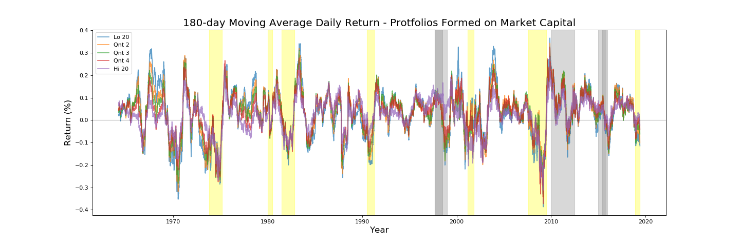

|  |
| --- |
| *Figure 3: Volatility of daily returns of quintile portfolios* |

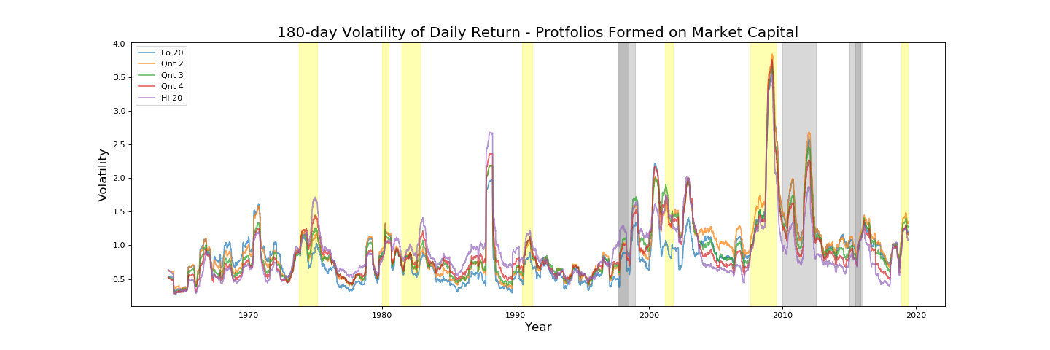

To explore the explanatory power of the five factor model with different portfolio groupings and sampling frequencies, we did regressions with portfolios that split the equity universe into 3 and 5 and 10 baskets based on market capitalization (size portfolios) and regressed each portfolio’s daily returns and monthly returns on the five factors (thus in total there are groups of regressions). Again, for regressions with daily returns, we adopted half-year rolling windows and for regressions with monthly data, we used 10-year rolling windows. We used the last date point of each rolling window to mark the regression. Figure 4 below are of each type of regressions.

|  |
| --- |
| *Figure 4: of Time-series regressions in Five Factor Model* |

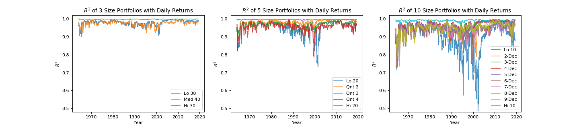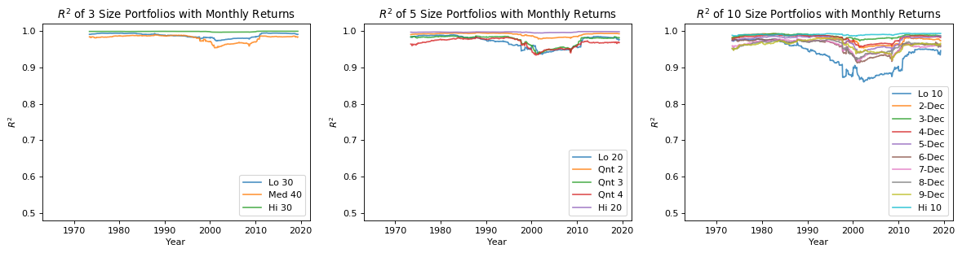

* The five factor model explains the market better with monthly data than with daily data. This observation holds across all time periods and all portfolio groupings. This is intuitive, as monthly returns average out the noises in daily returns a lot. Another observation is that the models using daily returns have higher than using monthly returns when the market is extremely volatile: for example, during the 2008 financial crisis, the daily return volatility reached a historical high and of the daily returns of the ten size-split portfolios are less divergent and almost all above 95%, while the of monthly returns of ten size-split portfolios ranged from 87% to 100%. It seems that, during financial crisis, though the market in general is more volatile, stocks with different market capital size tend to move closer together (as shown in moving average return and volatility plots), and probably the market factor or some specific risk factors became the major drivers of individual stock movements, i.e. the weight of size factor became smaller. The observations suggest that, in normal market conditions, monthly returns is easier to be explained by the five factor model, but for extreme scenarios like the 2008 financial crisis, the daily returns are explained more by five factor model.
* The finer we split the stock universe by size, the more diverge the five factor model’s performance is among size-split portfolios. For regressions with daily returns, the 3-4-3-split portfolios have very close around 95%, the quintile-split portfolios have ranged from 75% to 100%, and the decile-split portfolios have widely ranged from 50% to 100%. For regressions with monthly returns, the divergence is narrower, because monthly returns are easier to be explained as described in the first bullet point. But the divergence is still not negligible: for values, 3-4-3-split portfolios are all close to 100%, 95% to 100% for quintile-split portfolios and the decile-split portfolios range from 85% to 97%.
* The explanatory power of five factor model is stronger for big-sized stock portfolios and weaker for small-sized stock portfolios. Similar to the rationale of the first bullet point, the smaller size the listed company is, the more noisy its returns are, namely more sensitive to unsystematic risks, i.e. corporate financial risks, regulation changes or business risks, etc., and thus more difficult it is to explain their returns with the five factor model.
* Despite the largest-sized portfolio, the explanatory powers of five factor model on portfolios tend to move closer over time. Based on the trend of the , we can divide the history into four periods: the first one is before 1990 when the of five factor model was relatively stable; the second is from 1993 to 2000, where the explanatory power of five factor model declined after Fama and French published their three factor model in 1993; the third period is from 2000 to 2014, where the surged quickly back and remained at a high level; and the last period is post 2014 when the after crisis bull market started to become more volatile, and the started to drop again. To be rigorous, the way for the four periods splits is very subjective and we are not suggesting logical connections between the event of publishing a research paper and value change of of a particular model. However, we will provide some candidate factors that could potentially explain our observations: adoptions of factor investing in the US markets, ETF and Mutual funds market shares, development of factor models and level of publicity, development of data, technology and other infrastructures. A research by BlackRock on the factor investment revealed that from 2011 to 2014, the asset under management (AUM) of factor investment doubled, and from 2014 to 2017, the AUM of factor investment increased by 44% (Ang 2018). It is one of our hypotheses that the heavy use of the factor model as investment and trading strategies could artificially compress the risk premium on size, B/M (book-to-market) ratio, profitability and firms’ investment returns, and thus dilute the explaining power of five factors.

1. ***Explanatory power of individual factors***

The of five factor model are generally very high. However, we observed that not all the five factors are statistically significant enough across the whole testing period. Figure 5 below showed a binary indicator of whether the factor is significant at 95% level (1 stands for p-value < 0.05) in the linear regression model with daily returns and half-year rolling windows. Here we use the 3-4-3-split portfolios as an example.

It can be seen that the market excess return and SMB are always significant in any of the three portfolios. As summarized in the heat-map below, HML is significant around 50% of the time. RMW is significant around 65% of the time for the low-sized portfolio and high-sized portfolio, but is interpretative for the mid-sized portfolio. CMA is a factor that has the least significance occurrence: significant for only about 30% of the time.

Also, it can be observed from Figure 5 that when a factor is significant for a portfolio in one size bucket, it is not necessary that the factor is significant for portfolios in other size buckets. That is to say, size factor does not contribute homogeneously to the significance of other factors.

RMW, which measures the risk premium on firm’s profitability, are more significant during the 2008 financial crisis for the low-sized stocks. One possible explanation, if the observation we have is not due to randomness, is that during crisis time, the robustness of financial conditions for smaller companies weigh more than it usually is in normal market conditions.

|  |
| --- |
| *Figure 5:*  *Significance Occurrence of Five Factors (Daily Return)* |

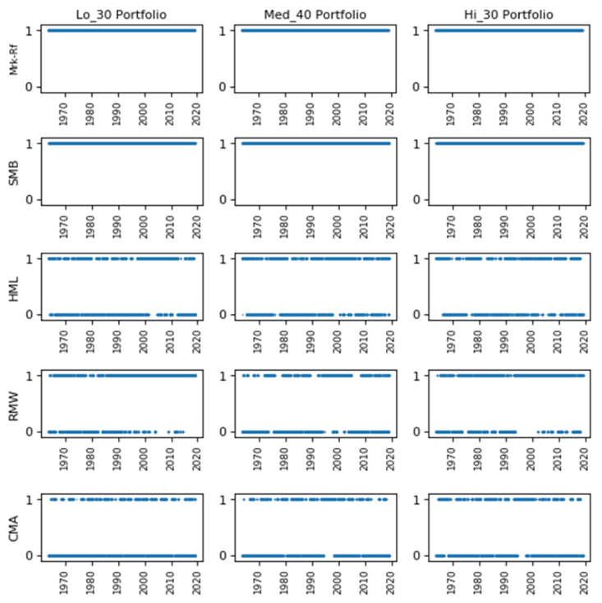

|  |
| --- |
| *Figure 6:*  *% of significance occurrence of factors (daily data)* |

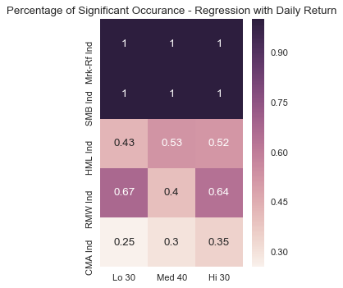

1. ***Correlation between factors***

Although not all the five factors are significant across time, it is very likely that the insignificant factor was well represented by other significant factors, considering the high correlations among the five factors by nature. Thus, we then looked at the linear relationships among the five factors by firstly doing OLS regression for each factor on the rest four through the whole time horizon. And in order to further explore the dynamics of the correlation pattern, we then did similar experiments by splitting the history into positive/negative months and by bull and bear markets we defined manually in the previous section. Finally, we examined the Pearson correlation between factors on a rolling window basis.

* 1. *Regression on the whole time horizon*

As shown in Figure 6 below, with both monthly returns and daily returns, the five factors present tight dependencies. With monthly data, all factors except for HML bring in statistically significant excess returns (reflected by the constant term) beyond the part of risk premium that can be explained by the other four factors. Take the market excess return as an example, except the portion that explained by SMB, RMW and CMA, it still contains 0.79% of monthly return that are unexplained to other factors. HML is the only factor that does not have a statistically significant constant term, which echoes many researches which claim HML factor is redundant (reference rebecco’s).

|  |
| --- |
| *Figure 6: Regression among 5 Factors with monthly data* |

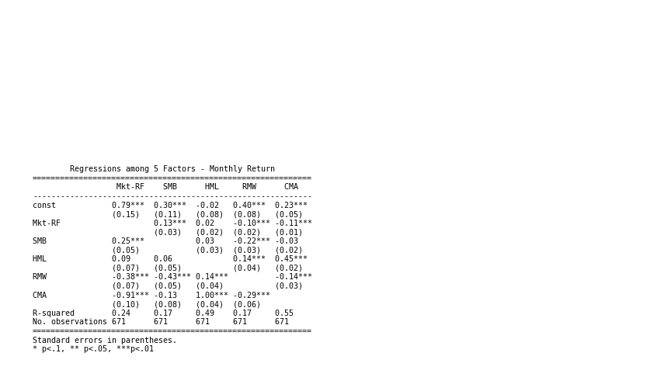

However, if we shift to daily data, the HML factor is saved, and actually all the five factors have statistically significant constant terms. And we can say that with daily data, the five factors are more tightly correlated with each other in terms that in each of the regression, all the four factors are always significant simultaneously. However, compared with monthly data, the with daily data is slightly lower, which is attribute to higher level of noise.

|  |
| --- |
| *Figure 7: Regression among 5 Factors with daily data* |

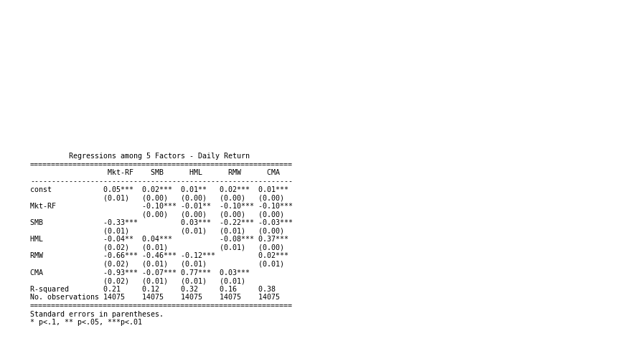

* 1. *Positive V.S. Negative Months*

Now we divided the history into two buckets, one contains the monthly periods when S&P 500 index or the target size portfolio had positive returns and the other for the negative returned months.

Figure 8 below summarized the regressions of three size factors when they have positive/negative monthly returns on the five factors. HML and RMW are not significant to the Low 30% size portfolio when it had negative monthly returns, and CMA is insignificant for any portfolios and any of the two scenarios. For all the three portfolios, the coefficient is larger in the negative-return periods than in the positive-return periods. SMB’s coefficient in positive and negative-return periods are similar for each portfolio. Another interesting observation is that HML and RMW will have coefficients in opposite sign in positive and negative returned periods. For HML, it implies that risk premiums for B/M ratio tends to bring extra positive/negative returns during positive/negative-return months. And similar for RMW, which measures the risk premium for robustness of companies’ profitability. Besides, the constant terms for all the regressions are significant, negative and large in magnitude, which means that there are specific risks that are not captured by the five factors, which is skewed to the positive side, i.e., tend to overestimate positive returns and underestimate negative returns.

|  |
| --- |
| *Figure 8:*  *Regression by Positive/Negative Portfolio Return Months* |

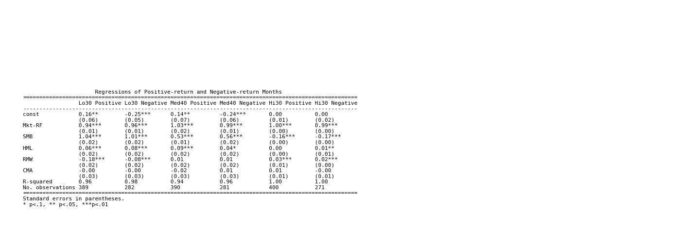

Figure 9 and 10 below show the linear relationships among the five factors by regressing each one of them w.r.t the other four during S&P 500’s positive-return months and negative-return months respectively.

* It can be seen that HML is redundant in both the positive returned periods and the negative returned periods. And CMA is redundant in the negative-return period only.
* The five factors are tightly dependent to each other, and the dependencies are higher in the positive-return periods.
* In the positive returned period, the coefficient of market excess return is always negative, and equivalently all the coefficients are negative in the regression of market excess return. A potential interpretation could be the better risk appetite on firms’ profitability and investment return will help the market boom further (or the causal relationship can be the other way round). But risk appetite for firm size seems to effect in an opposite way.
* In the negative-return scenario, the less risk appetite on firms’ size, B/M ratio and investment return tends to relieve some market downturn pressure (or it is the market downturn makes investors risk averse towards riskier firms with small size, low B/M ratio and aggressive investment).

|  |
| --- |
| *Figure 9:*  *Regression among Factors in positive S&P500 return months* |

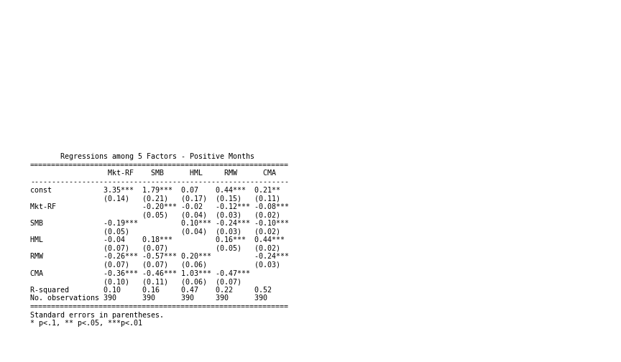

|  |
| --- |
| *Figure 10:*  *Regression among Factors in negative S&P500 return months* |

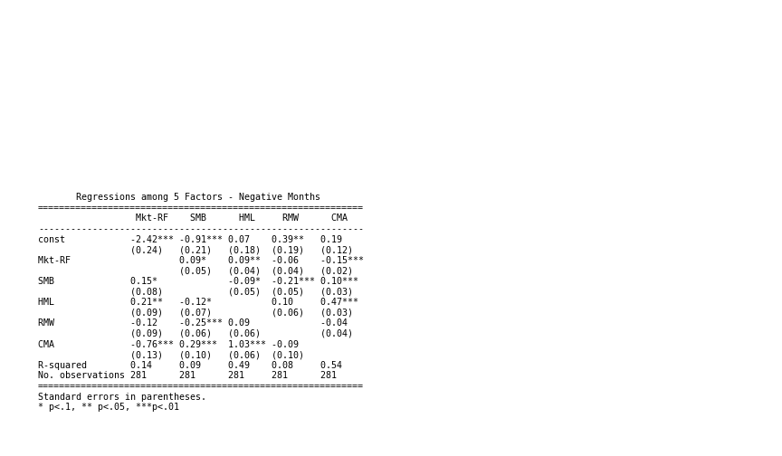

* 1. *Bull V.S. Bear markets*

We also did an analysis parallel to the above one but based on bull and bear markets division with daily data. A bull market is most commonly defined as a 20% S&P 500 rally after a 20% drop and before a second 20% decline in terms of S&P 500’s closing price.

In Figure 11 below, contrary to the positive-return and negative return scenarios, regressions in the bull and bear scenario mostly have insignificant and almost zero constant terms, which means that the five factors explained the portfolio return variations more comprehensively if we segment the history by bull and bear market scenarios and use daily data. This might due to the market factor playing a more important role as the data is divided by market performance, which reduced the weights for all other factors include specific risk. Besides, the market excess return and SMB tend to have non-distinguishable coefficients in a bull and bear markets for each portfolio. For the Medium 40% portfolio, HML and CMA mostly determined the different performance in bull and bear market. And for the Low 30% portfolio, HML and RMW are the major contributors. The High 30% portfolio’s performance does not seem to be affected that much across these risk factors.

|  |
| --- |
| *Figure 11: Regression by Bull/Bear periods (daily data)* |

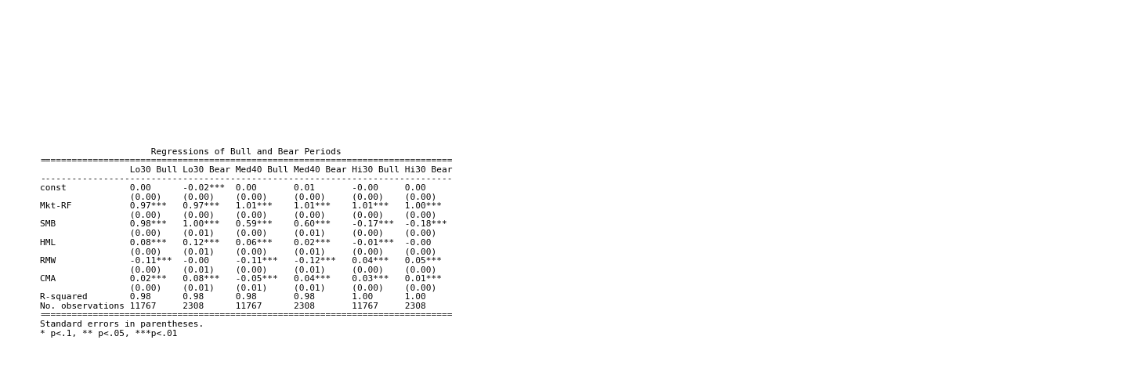

Figure 12 and 13 are summaries of the linear relationships between factors in bull and bear markets respectively. HML again seems to be redundant in both cases. But different from the positive/negative-month scenarios, RMW is redundant in the bear scenario, but CMA is not in both bull and bear scenarios. The take-away of how the risk appetite affects the market returns in bull and bear markets (or how the market regimes affect investors’ risk appetites) is similar to that in the positive/negative-month scenarios.

|  |
| --- |
| *Figure 12: Regression among Factors in Bull Periods* |

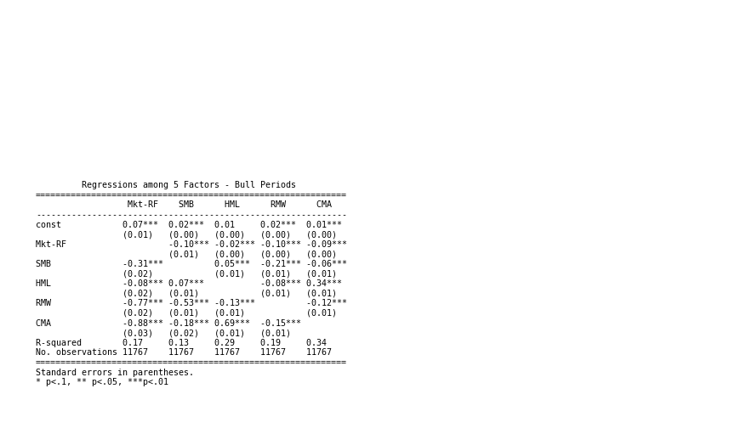

|  |
| --- |
| *Figure 13: Regression among Factors in Bear Periods* |

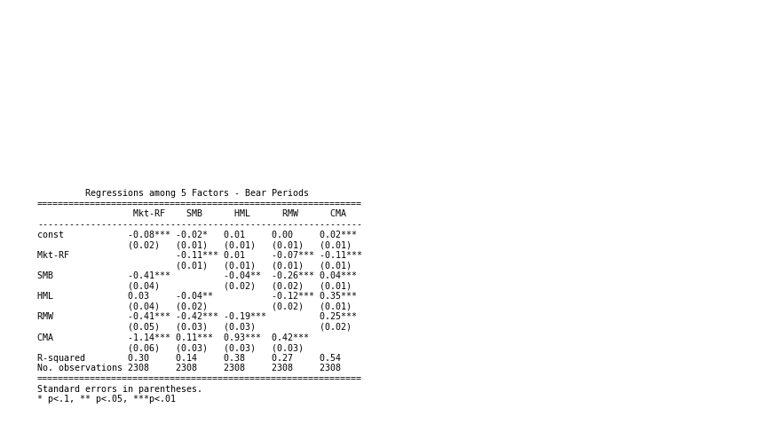

* 1. *Pearson Correlation between factors over time*

To better observe the correlation between the factors pairwise and how the correlations vary over time, we calculated the Pearson correlation of daily returns for each pair between the five factors on a rolling window basis. A quick glance at Figure 14 may suggest you to look at around year 1995, as it seems to be a time when the correlations between factors shifted dramatically. Some factors may even have correlation turned from negative to positive or the other way round since 1995. 2008 financial crisis seems to be another turning point of some correlations. Trying to explain the patterns if there are any, are difficult, but a relatively safer conclusion is that the correlation structure is extremely unstable and should heavily depend on market regimes.

|  |
| --- |
| *Figure 14: Pearson Correlation among 5 Factors* |

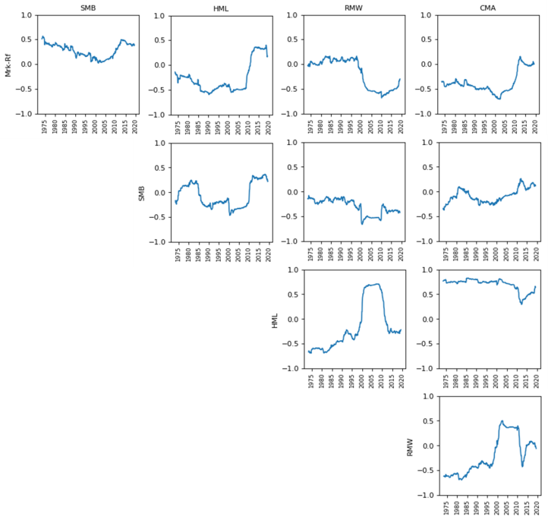

***Conclusions and Future Plan***

We

* Most of the factors have risk premiums that are not explained by market excess return or the four other factors.
* Not all the factors are always significant over all market scenarios. Largely depend on bull/bear and positive/market
* The fitness of five factor model largely depends on scenarios.
* Factors are correlated and correlation may depend market regimes.

But with limited access to single stock pricing data and fundamental data,

* Look at five factor model at single-stock level
* Look at more factors, including short interest, sentiment, volatility, momentum, growth
* Try different stock universe, S&P 500, Russel 2000
* Look at global markets
* Try machine learning method with factors
* Granular classifications of historical events, not only for financial crisis but other major events that affect financial markets
  + Fed Interests hike
  + Trade war

# References

Ang, Andrew. 2018. June 5. https://www.blackrock.com/us/individual/investment-ideas/what-is-factor-investing/factor-commentary/andrews-angle/factor-growth.

Francis Breedon, Louisa Chen, Angelo Ranaldo, Nicholas Vause. 2018. *Judgement Day: algorithmic trading around the Swiss franc cap removal.* Bank of England.

Irwin, Neil. 2011. September 30. https://www.washingtonpost.com/business/economy/us-economic-recovery-tied-to-european-debt-crisis/2011/09/29/gIQAAIAEBL_story.html?noredirect=on&utm_term=.d29ea3b844cd.

Stracca, Livio. 2013. *The Global Effects of the Euro Debt Crisis.* European Central Bank.